## Guidance for RFP Template

### Introduction

The purpose of this document is to provide guidance for developing the fillable portions of the Purchasing and Contracting (P&C) Request for Proposals (RFP) solicitation template document, including:

* Attachments
* Developing the Introduction
* Writing the Scope of Work
* Specifications
* Contractor Performance Expectations
* Establishing District Deliverables
* Additional Sections
* Proposal Content/Requirements
* Evaluation Criteria
* Number of Evaluators

Contents

Guidance for RFP Template 1

Introduction 1

Attachments 3

Standard Attachments 3

Additional Attachments 3

Developing the Introduction 4

Solicitation Purpose 4

Multiple Contracts 4

Additional Terms 4

Scope and Statement of Work 5

Purpose 5

Scope of Work vs. Statement of Work 5

Methodology 6

Building on Past Work 7

Specifications 7

Contractor Performance Expectations 7

Establishing District Deliverables 8

Additional Sections 8

Proposal Content/Requirements 8

Evaluation Criteria 9

Tier 1 Evaluation Criteria 10

Additional Tier Evaluation Criteria 11

Number of Evaluators 12

Conclusion 12

### Attachments

Figure 1: Attachment Listing (Page 3 of RFP Solicitation Template)

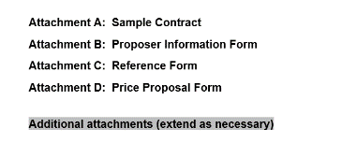

#### Standard Attachments

As part of the standard solicitation, the following attachments should be included with each RFP solicitation:

* **Attachment A: Sample Contract** – A sample of the contract expected to result from the solicitation. For example, a solicitation for engineering should include a sample copy of the standard Engineering contract template.
* **Attachment B: Proposer Information Form** – Standard form to be included by P&C
* **Attachment C: Reference Form** – Standard form to be included by P&C
* **Attachment D: Price Proposal Form** – Variable form to encompass the pricing element of the solicitation, to be developed by the solicitation manager (SM) in conjunction with P&C
  + Considerations:
    - Will more than one contractor be awarded a contract?
    - Is the form easy to understand and fill out?
    - ***Note: Division 48 Architecture and Engineering Solicitations should NOT include a request for pricing***

#### Additional Attachments

Sometimes it may be necessary to include additional attachments. The following are examples of such attachments. It is up to the discretion of the SM to include additional attachments as needed.

* Forms verifying any licenses or certifications required for the work
* Applicable product/company safety information

### Developing the Introduction

The introduction is a short section of the solicitation that tells participating contractors the purpose of the solicitation and the district’s expectations.

Figure 2: Introduction Section (Page 4 of Solicitation Template)

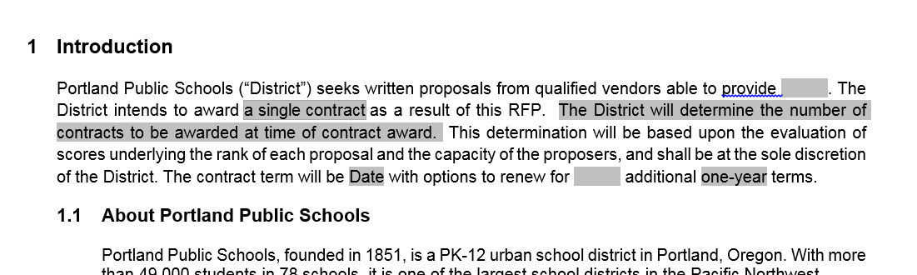

#### Solicitation Purpose

Include a brief description of the services expected to be procured from the solicitation. This should be a short statement only, as the full scope of work will be addressed in a later section.

#### Multiple Contracts

Consider whether a contract will be awarded to a single contractor for all the services included in the solicitation, or whether multiple contracts will be awarded. The primary reasons for awarding multiple contracts are as follows:

* Diversify the pool of contractors in order to:
  + Cast a wider net for availability of services, as one vendor/form may not have the staff capacity to do all work needed in a timely manner
  + Limit dedicating entire district financial resources to one entity
* Obtain best pricing for individual items included in the solicitation (e.g., Contractor A may provide less costly services as to one portion of the scope of work, while Contractor B may be more cost-effective as to another portion)

Whether the contract is to be awarded to one contractor or multiple contractors, this critical section sets the expectations for participating contractors, avoids ambiguity, and limits district exposure to disputes at contract award.

#### Additional Terms

To protect the district from entering a long-term agreement with a contractor that fails to meet expectations during the first period of a contract, Portland Public Schools allows in the solicitation documentation the option to renew contracts for additional terms. Typically, solicitations including this language will originate as a one-year agreement, renewable for up to four additional years at the district’s option, providing enough protection for the school district without de-incentivizing proposals.

### Scope and Statement of Work

The scope and statement of work section of the document is the component of the RFP template requiring the most input from the SM. Because of the SM’s departmental knowledge and subject matter expertise, the SM is uniquely qualified to establish the scope of services requested in the RFP. P&C will review the final document and evaluate whether or not the scope is clear and presented logically, but it is up to the SM to ensure that all services expected from the contractor are included in this section. See Figure 3: Scope of Work Page 6 of Template for a snapshot of this section of the RFP template.

Figure 3: Scope of Work Page 6 of Template

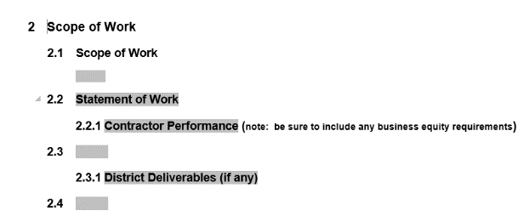

#### Purpose

When writing the scope of work, bear in mind that the purpose is to provide guidance at the RFP stage to assist proposers in understanding the work to be undertaken and to facilitate the development of detailed, responsive proposals. The scope of work will be important to carry through to the contract stage as well, setting up enforceable guidance to the contractor. The contents and structure of the scope are influenced by the type of resulting service/product.

The scope section describes the logical boundaries within which the work will take place (i.e., what is the work, and what is it not?).

#### Scope of Work vs. Statement of Work

Scope of work is meant to provide a brief overview of the project itself, while the statement of work section shown in Figure 3 is meant to provide extended detail about the work to be performed. For example, a solicitation for tutoring services would have a scope of work that briefly explained the need for tutoring students, while the statement of work would go into the details of how the tutoring would be expected to be conducted, how it would be monitored and maintained, and all requirements, subject matter, and other details pertinent to the actual work to be performed.

In many cases, separating these two sections makes sense. In other cases, combining this into one “Scope of Work” section is perfectly acceptable. The SM can make that determination, and P&C is more than willing to help determine the best way to organize this section of the solicitation document.

#### Methodology

Keep the following methods and concepts in mind when writing the scope of work:

* Write in a sufficiently detailed manner, so as to provide enough of a basis to differentiate between competing proposers during proposal evaluation. However, try not to be overly prescriptive in your description of the work if the project is to be performance-driven. It is important to be clear and descriptive, but to leave proposers the flexibility to differentiate themselves from competitors and to “own” the work. Being too precise can lead to finger-pointing later if the contractor follows exact instructions instead of using expertise to guide a successful completion.
* Frame the required work within the context of the professional discipline in which it is situated. Provide a brief description of the discipline to ensure understanding of the requirements to successfully undertake the work within this broader field.
* For each activity described, provide the scale and metrics (e.g. identify the frequency, quantity or volume of inputs the Contractor is required to make) for the successful completion of the work. For anticipatory service/product, all Scope activities will be “as required.”
* Reserve the organization’s right to amend the scope at a later date, to include additional related input or scope parameters, should the need arise due to a change in business or technical requirements. However, any item that is anticipated as a requirement at the time the solicitation is developed should be included within the solicitation document.
* Think ahead to the contract management stage (once the highest-scoring offeror has been selected, the contract is signed, and the work is underway). Once the contract is underway, a well written scope of work will go a long way to minimizing potential misunderstandings and/or disputes with the contractor.
* Use generic (non-proprietary) terminology and references in describing requirements. This enables greater competition and mitigates the risk of a bid challenge or allegation that the requirements were slanted to a particular bidder.
* Use the present/active tense, as the document needs to survive the solicitation process and move forward through the contract. The words “will” and “shall” have specific meanings that can be used to convey a binding provision on the contractor (i.e. “The contractor shall supply...”).

#### Building on Past Work

Work with P&C or other members of the department to establish whether or not a prior solicitation has been issued for the work. While sometimes this is not the case, often there are documents from prior work that can serve as the basis for the scope of work on a new solicitation. While it is important to ensure that each solicitation be given the specific attention necessary to fulfill the requirements of the project, there is no reason to re-invent the wheel each time a new project arises. Keep in mind the following before starting a scope of work from scratch:

* Is there a current, expiring contract that has led to this solicitation? If so, there may be a prior solicitation for the same work.
* If there was a contract in place for this service, where was the contract effective? Where was it lacking? Finding ways to improve the contract for the next duration often begin with evaluating the current one.
* Is there an entity with similar needs/regulatory requirements that has done a recent solicitation? These documents are often publically published and they can help determine the type of information to include in the scope of work.

### Specifications

Specifications are the SM’s opportunity to provide the specific requirements that must be adhered to for a successful project that meets district rules and personnel expectations. Specifications will vary significantly based on the type of project included in the solicitation. Sometimes, specifications are inherently included in the scope of work, while in most situations, it makes sense to call them out separately. The following are the most common ways in which specifications are included in the solicitation documentation:

* As a separate section, added to the space shown in Figure 3
* As a separate attachment, added to the space shown in Figure 1
* As a reference to an established space such as the PPS shared google drive – e.g., reference the PPS Design Standards by reference:
  + <https://drive.google.com/drive/folders/0B2vrIMdSVqNEflZOZkpOUDNhcWJtVXVPNDhXanhmTFlMYllWOFVWOTQ2OVpFSEZDZnp5d0E>
  + This can be referenced in its own section, as a separate attachment, or within the scope of work section of the document

Specifications should include the very specific technical requirements key to successful completion of the project or task. This should include any regulatory requirements, as well as standards and practices critical to ensuring quality products and services in line with the mission of the district.

### Contractor Performance Expectations

This section is not required, but may be useful to include in a solicitation. The purpose of the contractor performance section is to clearly define some or all of the following expectations:

Contractor deliverables, noting that this section should be focused on deliverables during the contract, rather than deliverables for this solicitation, which are addressed through the Proposal Content/Requirements section of the solicitation.

* Any required inspections or quality control measures
* Any equity requirements or aspirations not already stated elsewhere in the document
* Additional requirements necessary (Buy American Act compliance, prohibited ingredients or products, etc.)
* Ongoing service requirements (drop-off time periods and locations, response times, etc.)

This information should work in conjunction with any additional information provided, as in a project schedule or a condition for payment, as applicable.

### Establishing District Deliverables

This section is to establish any deliverables the contractor can expect the district to provide. Examples may include, but are not limited to the following:

* The district will provide a request for product within 24 hours of expected delivery
* The district will provide environmental testing results prior to work commencement
* The district will provide log-in information for software necessary for tracking quality control
* The district will provide temporary office space for the duration of the project at a set location

Defining the expected role of the district during the duration of a contract can help mitigate contract disputes in the long-run and should serve as a supporting section of the solicitation, helping to clarify the scope of work, pre-empt potential questions of contractor responsibility, clearly define roles of all parties involved, and limit overall ambiguity during the project.

### Additional Sections

### The document, as shown in Figure 3, provides the space to additional sections pertinent to the scope of work, or to set other requirements necessary and specific to the needs of the work to be performed, such as scheduling requirements or key milestones Proposal Content/Requirements

As shown in Figure 4, the proposal content table is a critical component of the solicitation. This table tells the proposer exactly what needs to be included in their proposal. When evaluating whether something should be mandatory, scored, or optional, keep in mind the evaluation process. If an item is to be part of the evaluation criteria, but the absence of the item should not disqualify the contractor from participation in the solicitation, then checking the box for “Scored” may be the best option. Conversely, if the item is critical for the proposer to submit in order to be responsive, then checking the box for “Mandatory” should be considered. Note that P&C will evaluate all proposals for responsiveness based on this table. If an item has “Mandatory” checked and it is not included, P&C will disqualify the bid, labeling it is non-responsive. Any item missing that is not checked “Mandatory” in this table will not cause P&C to label the bid as non-responsive.

Figure 4: Proposal Content Table (Page 7 of Template)

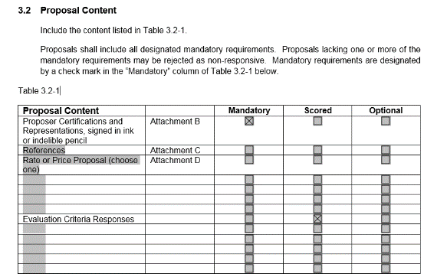

P&C requires Attachment B to be a Mandatory component of a responsive proposal. Please consult P&C before deviating from this practice.

### Evaluation Criteria

Thoughtful definition of the evaluation criteria in the solicitation documentation helps to ensure fairness in the solicitation process. The evaluation criteria sets parameters for the evaluation team, and also communicates to proposers the exact information they need to address and prioritize in order to effectively produce a competitive proposal. Most of the criteria is part of what is called the written evaluation, also called Tier 1, while Tier 2 criteria is generally reserved for interviews. Each section of the template chart, as shown in Figure 5, provides guidance for typical criteria used to evaluate solicitations.

Figure 5: Tier 1 Table (Page 8 of Template)

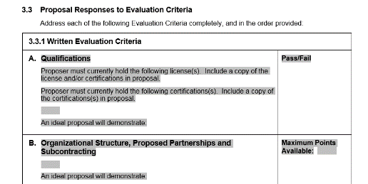

#### Tier 1 Evaluation Criteria

Tier 1 criteria, also referred to as the written evaluation criteria, encompasses the majority of the submitted items from the proposer, to include pricing, references, qualifications, and any required and/or scored attachments requested in the solicitation. Each section should be applied a points total or a pass/fail grade, and it is up to the SM to determine the points system and the evaluation criteria.

##### Evaluation Criteria

The following are some recommendations to help guide selection of evaluation criteria:

* In each category, consider the applicability of the criteria for the specific solicitation
* Consider any points areas that give too much advantage to one type of proposer
* Avoid categories that create all-or-nothing situations for the proposer from a scoring perspective
  + Such situations may be best addressed with a mandatory requirement, or altered to be to provide proposers the ability to make efforts toward the goal

##### Points Determination

The following are some recommendations to help guide selection of points values. These are recommendations, are not comprehensive, and are not mandatory, but should serve as a guide to assist the SM in allotting points.

* Pass/Fail
  + When using pass/fail, think of items that have only a yes or no response, such as:
    - Does the contractor hold a certification?
    - Is the contractor licensed to do the work?

Keep in mind the potential for duplication when using pass/fail as an assessment option. If these items have been identified as mandatory in another portion of the document, it is not always necessary to list them in the Written Evaluation Criteria as well. In fact, some of these items may be better suited to the requirements section of the solicitation.

* Points
  + Use round numbers whenever possible to make scoring easier for all involved (i.e. use 100 points, instead of 117 points)
  + Start with total points to assign the entire project (i.e. 600), then assign points based on a weighted percentage of all the criteria (i.e. if the SM wants the references to be 10% of the weight of the proposal, then award 10% of the 600 points – or 60 points – to the references section). Once again, use round numbers in the percentages, and ensure all percentages applied add up to 100% total.
    - Don’t forget the weight of any additional tiers of evaluation when assigning points
  + The lower the points total, the less variation will be allowed for ranking proposers. This can be useful in some instances, but providing a wide enough range of ranking will allow for differentiation. Too large of a number can make it hard to justify the swing in points, so it’s important to choose something reasonable and easy to score. Each category ranging from 20-300 points is usually appropriate.

#### Additional Tier Evaluation Criteria

Tier 2 should be considered any additional criteria requirement that is to be scored separately from the written criteria. Tier 2 criteria is most often in the form of interviews with, or demonstrations from, the top proposers. P&C is available for assistance in determining whether Tier 2 evaluation criteria is applicable to the solicitation. If no interviews or demos are expected for the solicitation, simply delete the table shown in Figure 6..

Figure 6: Tier 2 Table (Page 11 of Template)

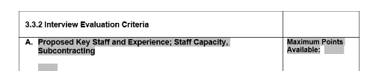

At times, additional tiers of evaluation may be required, including for demonstrations, product samples, and site visits. This is what the sections shown in Figure 7 are for. As with Tier 2, should these additional tiers not be required, delete the added tables from the template.

Figure 7: Additional Tiers Tables (Page 11 of Template)

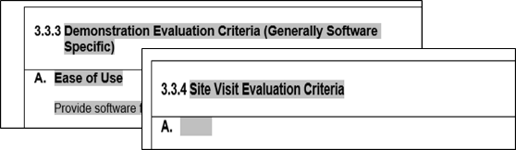

### Number of Evaluators

An evaluation committee is established in order to fairly evaluate each responsive proposal received during an RFP. The SM may include as many evaluators as necessary for a comprehensive evaluation, but P&C typically recommends three to five evaluators. If accepting hardcopy proposals, requesting additional copies for each evaluator in the part of the solicitation shown in Figure 8 not only helps identify the evaluation expectations early in the process, but also places the hard-copy creation responsibility on the bidder.

Figure 8: Page 12 of Template

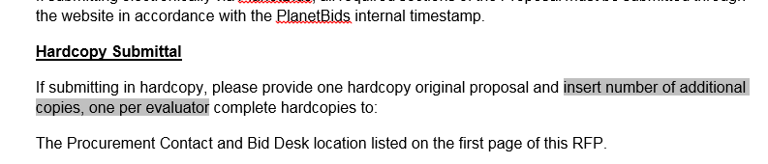

Choosing the evaluation team should include the following considerations:

* Key departmental staff
* Subject-matter experts
* Personnel with unique insight or knowledge of the specific project or service
* Community member who can provide stakeholder input from a different perspective

### Conclusion

Once the document draft is complete, send to P&C for review. It is common for P&C to follow up with clarifications, questions, and corrections as the solicitation progress should be a collaborative effort to ensure the best possible project for all parties involved. After all parties are in agreement as to the final draft of the solicitation and all attachments to be included, P&C will post the solicitation on Planet Bids, and schedule the bid opening time and location. It is the responsibility of the SM to provide P&C with any prospective bidders and contact information, should the SM wish P&C to contact bidders directly for notification of solicitation posting.